PROJECT REPORT
AI-BASED PLANT DISEASE DETECTOR USING DEEP LEARNING

ABSTRACT
Agriculture is a fundamental sector that sustains a large portion of the global population, particularly in countries like India where the majority of rural livelihoods depend on farming. A major challenge faced by farmers is the early detection and diagnosis of plant diseases, which have the potential to drastically reduce crop yield, quality, and overall productivity. Traditional disease identification methods rely heavily on manual visual inspection by agricultural experts. These methods are often slow, costly, subjective, and inaccessible to small-scale farmers who lack immediate expert support. Therefore, there is a clear need for automated, fast, and reliable systems that can assist farmers in identifying plant diseases at early stages.
In this project, we present an AI-Based Plant Disease Detection System that uses deep learning techniques to classify diseases from plant leaf images. A Convolutional Neural Network (CNN) is trained on a diverse and widely used dataset containing images of healthy and diseased leaves of crops such as tomato, potato, and pepper. The model processes leaf images, extracts features autonomously, and classifies them into one of fifteen disease categories with high accuracy. Advanced preprocessing techniques, including image resizing, normalization, and augmentation, were applied to improve model generalization and robustness. The trained model is then integrated into a user-friendly Streamlit web application, which enables users to upload leaf images and receive real-time predictions along with disease remedies and confidence scores.
The proposed system offers rapid disease detection, high accuracy, and accessibility through a simple interface that farmers and students can easily use. It significantly reduces the dependency on agricultural experts and helps prevent large-scale crop losses by enabling early diagnosis and timely intervention. This AI-powered solution demonstrates the potential of deep learning in precision agriculture and paves the way for intelligent farming tools that can support sustainable agricultural practices and enhance productivity. The project also highlights opportunities for future expansion through mobile deployment, support for additional crops, and integration with IoT-based farm monitoring systems.

CHAPTER 1
INTRODUCTION

Agriculture forms the backbone of many developing nations, especially India, where a large portion of the population depends on farming for their livelihood. Ensuring high crop yield and quality is therefore essential for economic stability and food security. However, plant diseases continue to pose a serious threat to agricultural productivity. Diseases caused by fungi, bacteria, and viruses can rapidly spread across fields, leading to substantial losses if not identified and treated in time. Traditional disease detection relies on visual inspection by farmers or agricultural experts, which is often inaccurate, time-consuming, and impractical, especially in rural areas where expert access is limited. This gap creates an urgent need for automated and reliable solutions capable of assisting farmers in identifying diseases early.
Artificial Intelligence (AI), particularly deep learning, has emerged as a powerful tool for solving image-based classification problems. Convolutional Neural Networks (CNNs) have demonstrated exceptional performance in recognizing complex patterns in images, making them ideal for plant disease detection tasks. By training on large datasets, CNNs can automatically learn distinguishing visual features of healthy and diseased leaves, offering more consistent and accurate predictions compared to manual inspection. Several research studies have shown that AI-driven plant disease detection systems can significantly reduce uncertainty and help farmers take timely action.
This project focuses on developing an AI-Based Plant Disease Detector capable of classifying plant leaf diseases using deep learning techniques. The system is trained using the widely used PlantVillage dataset, which contains thousands of labelled images of healthy and diseased leaves of crops such as tomato, potato, and pepper. A custom CNN model is designed and optimized for high classification accuracy. To make the system user-friendly and accessible, the model is deployed using a Streamlit web application, allowing users to upload leaf images and instantly obtain predictions along with confidence scores and recommended remedies.
The primary objective of this project is to provide a reliable, cost-effective, and easy-to-use diagnostic tool that assists farmers, students, and agricultural professionals. The model helps identify diseases at an early stage, enabling effective intervention and reducing crop losses. The system also contributes to promoting precision agriculture and highlights the potential of AI in modern farming practices. This project not only demonstrates the effectiveness of deep learning in solving agricultural challenges but also opens opportunities for future enhancements such as mobile app deployment, multi-crop support, and real-time field monitoring.

CHAPTER 2
LITERATURE REVIEW

Plant disease detection has been an active area of research in agricultural engineering and computer vision. Traditional approaches relied heavily on manual inspection by experts, which suffers from subjectivity, inconsistent accuracy, and high time consumption. As a result, researchers began exploring computational techniques to automate disease diagnosis. Earlier attempts used classical machine learning methods such as Support Vector Machines (SVM), K-Nearest Neighbors (KNN), and Random Forests with handcrafted features like color histograms, texture descriptors, and shape features. However, these methods struggled to capture complex visual variations in plant leaves, especially under different lighting conditions and environmental backgrounds.
The emergence of deep learning has significantly transformed image-based disease detection. Sladojevic et al. (2016) were among the first to apply Convolutional Neural Networks (CNNs) for plant disease classification. Their model, trained on leaf images of 13 crops, achieved high accuracy and demonstrated the power of deep learning for automated detection. Similarly, Mohanty et al. (2016) used transfer learning models such as AlexNet and GoogleNet on the PlantVillage dataset, reporting accuracy levels above 99%. These studies established CNNs as a highly effective approach due to their ability to learn hierarchical features directly from images, eliminating the need for handcrafted feature extraction.
Further advancements were observed in Ferentinos (2018), who trained deep neural networks on more than 87,000 images and achieved up to 99.75% accuracy across 25 plant species. His work demonstrated the scalability of deep learning-based detectors and reinforced their effectiveness in real-world agricultural applications. Recent research has also incorporated data augmentation techniques to increase dataset diversity and robustness. Studies by Too et al. (2019) and Kumar et al. (2020) highlight the effectiveness of transfer learning approaches such as VGG19, ResNet50, and EfficientNet, which significantly improve performance even with limited training data.
More recent works have explored integrating AI systems with IoT and mobile devices to enable real-time field diagnosis. Researchers have proposed smartphone-based scanning systems, drone-assisted disease detection, and cloud-based AI services for large-scale agricultural monitoring. These advancements reflect a strong trend toward precision agriculture, where AI plays a central role in improving crop management and reducing losses.
In summary, the literature consistently demonstrates that deep learning—particularly CNN-based architectures - offers the most accurate and reliable solution for plant disease detection. Unlike traditional machine learning, CNNs automatically extract relevant features, making them suitable for diverse real-world conditions. The existing studies strongly support the development of an AI-based plant disease detection system, validating both the methodology and expected outcomes of this project.

CHAPTER 3
METHODOLOGY

The methodology of this project is designed to build a complete end-to-end AI system capable of detecting plant diseases from leaf images. The process consists of several stages, including dataset acquisition, preprocessing, model design, training, evaluation, and deployment through a Stream lit-based web application. Each phase is essential for achieving accurate, reliable, and real-time plant disease identification.

3.1. Dataset Collection
The model is trained on the PlantVillage dataset, a widely used and publicly available collection of high-resolution images of plant leaves. It includes images of several crops such as tomato, potato, and pepper, categorized into multiple disease classes and healthy classes.
The project uses the following 15 classes:
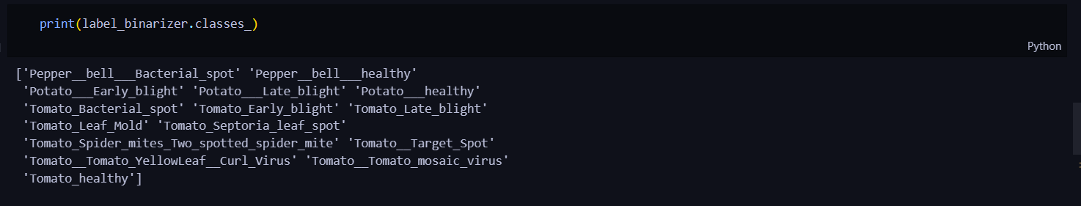
The dataset is divided into training, validation, and testing subsets to ensure fair and unbiased model evaluation.

3.2. Data Preprocessing
To ensure consistency and robustness, each input image undergoes several preprocessing steps:
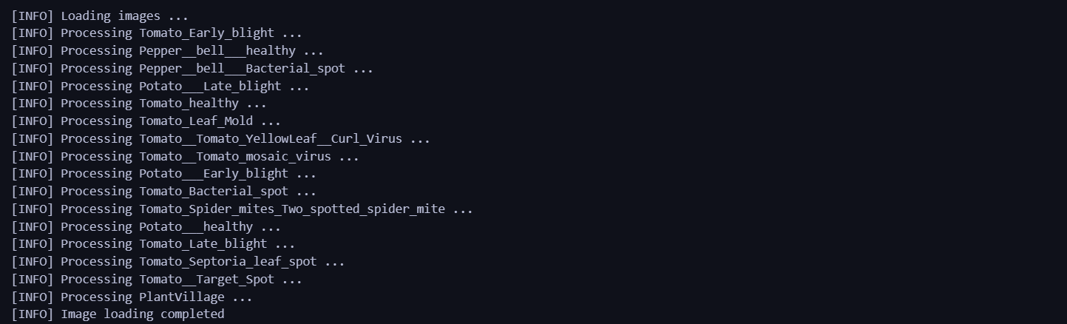

3.2.1 Image Resizing
All images are resized to 256 × 256 pixels to match the CNN input shape.

3.2.2 Normalization
Pixel values are scaled between 0 and 1 by dividing by 255. This speeds up training and improves stability.

3.2.3 Data Augmentation
To prevent overfitting and increase generalization capability, several random transformations are applied:
- Rotation (20–40 degrees)
- Horizontal & vertical flipping
- Zooming
- Shearing
- Brightness variation
Data augmentation ensures that the model performs well across varying environmental conditions.

3.3. Model Development
A Convolutional Neural Network (CNN) is used for image classification due to its superior ability to extract features automatically from images.

3.3.1 CNN Model Architecture
The architecture consists of the following layers:
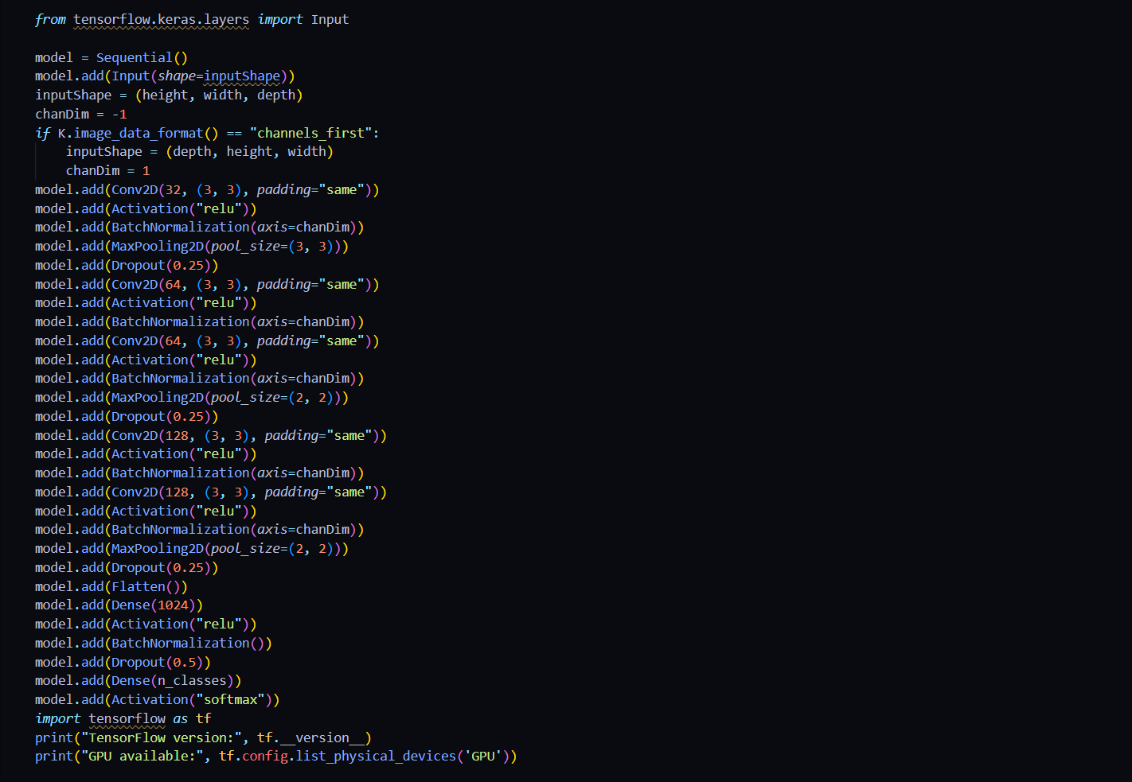
- Convolution Layer + ReLU + Batch Normalization
  - Extracts edges, shapes, and textures.
  - Normalization stabilizes network learning.
- Max-Pooling Layer
  - Reduces image dimension.
  - Retains important spatial features.
- Dropout Layer
  - Prevents overfitting by randomly deactivating neurons.
- Multiple Convolution Blocks
  - 32 → 64 → 128 filters to extract increasingly complex patterns.
- Flatten Layer
  - Converts feature maps to a 1D vector.
- Fully Connected Dense Layer (1024 neurons)
  - Learns deep patterns and relationships.
- Output Layer (15 neurons with Softmax)
  - Provides probability distribution across all classes.
The model is trained using the Adam Optimizer with Categorical Crossentropy Loss.

3.4. Model Training
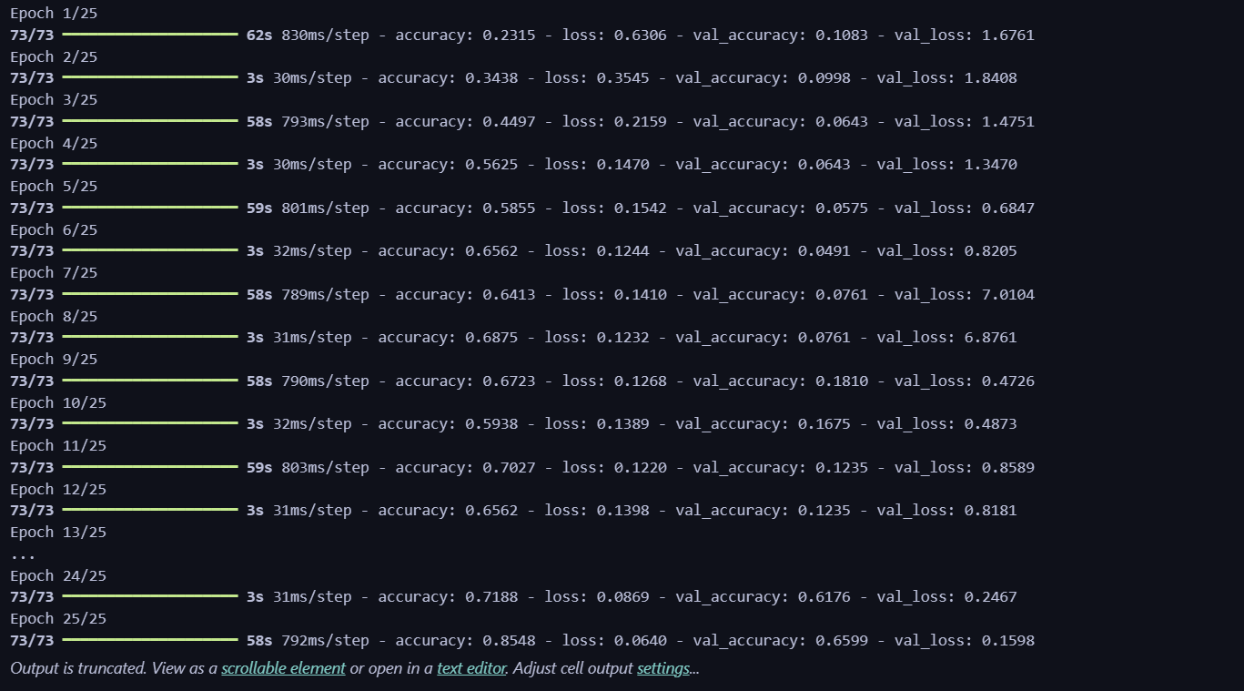

Training is performed on the preprocessed dataset using the following setup:
- Batch size: 32
- Epochs: 25
- Validation split: 20%
- Callbacks: EarlyStopping, ModelCheckpoint

3.4.1 Training Objectives
- Minimize loss
- Maximize prediction accuracy
- Avoid overfitting
- Improve generalization
During training, model performance is monitored using loss and accuracy on the validation set.

3.5. Model Evaluation

After training, the model is evaluated using:
- Accuracy
- Precision, Recall, F1-score
- Confusion matrix
- Test dataset performance
These results confirm the model’s ability to classify leaf diseases reliably.

3.6. Deployment Using Streamlit
To make the system easy to use, the model is integrated with a Streamlit web application.
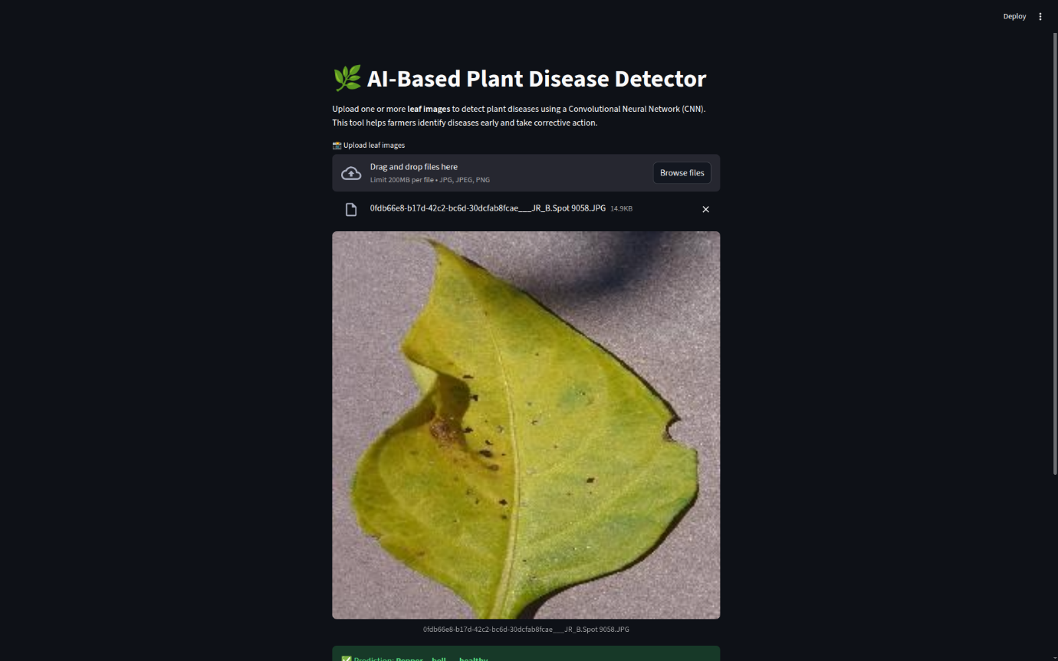

3.6.1 User Interface Flow
- User uploads one or multiple leaf images.
- Images are displayed on the screen.
- Preprocessing is applied in real-time.
- The CNN model predicts the disease class.
- The application displays:
  - Predicted disease
  - Confidence percentage
  - Suggested remedy
- A CSV report can be downloaded for multiple images.

3.6.2 Backend Integration

The app loads the trained model, processes images using the same preprocessing pipeline used during training, and returns index-to-class mapping based on stored label encodings.

3.6.3 Remedies Module
A dictionary of remedies is included to give farmers immediate corrective actions.
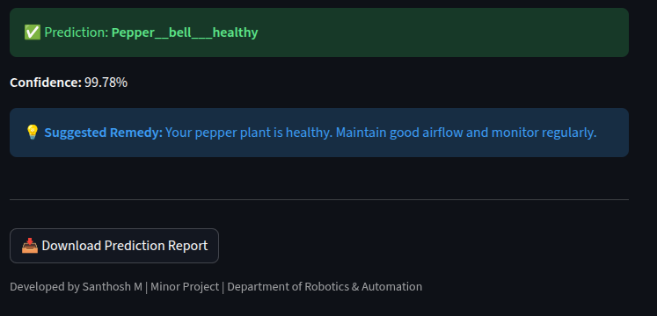

3.7. System Workflow
A simplified workflow of the system:
Leaf Image Upload
│
▼
Image Preprocessing
│
▼
CNN Disease Classifier
│
▼
Predicted Class + Confidence Score
│
▼
Remedy Suggestion & Report Generation
│
▼
Streamlit User Interface

3.8. Summary
The methodology successfully integrates deep learning, image processing, and interactive web deployment into a powerful, real-time disease detection system. By combining a robust CNN model with a friendly interface, the proposed solution is suitable for practical agricultural use and can be expanded in future for mobile deployment, drone-based monitoring, and multi-crop support.

CHAPTER 4
SYSTEM REQUIREMENTS AND IMPLEMENTATION
4.1 Hardware Requirements
- Laptop / PC
- 16 GB RAM (minimum)
- 4 GB GPU (minimum)
4.2 Software Requirements
- Python 3.10+
- TensorFlow
- Keras
- Streamlit
- NumPy, Pandas, PIL
- Jupyter Notebook

4.3 Model Training
The model was trained using TensorFlow/Keras.
After training, the model was saved as:
- cnn_model.pkl (pickled version)
4.4 Streamlit Web Application
The frontend is built using Streamlit to provide:
- Image uploader
- Prediction display
- Confidence percentage
- Suggested remedies
- CSV export for batch predictions

CHAPTER 8
RESULTS AND OUTPUTS
The AI-Based Plant Disease Detection System was evaluated using the trained Convolutional Neural Network (CNN) model and the Streamlit-based web application. The model’s performance was assessed on a separate test dataset consisting of plant leaf images belonging to the same 15 classes used during training. The results demonstrate the effectiveness of the system in accurately identifying plant diseases from leaf images and providing corresponding remedies.
8.1 Performance Metrics

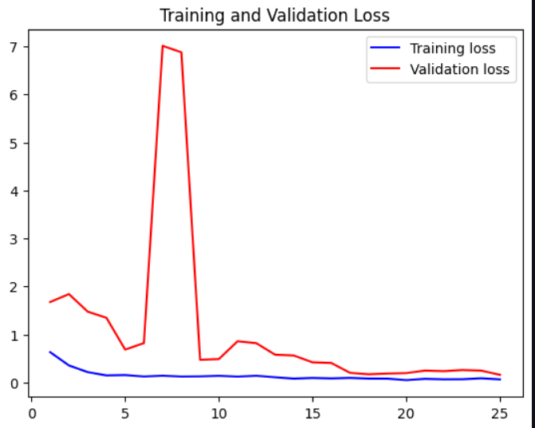
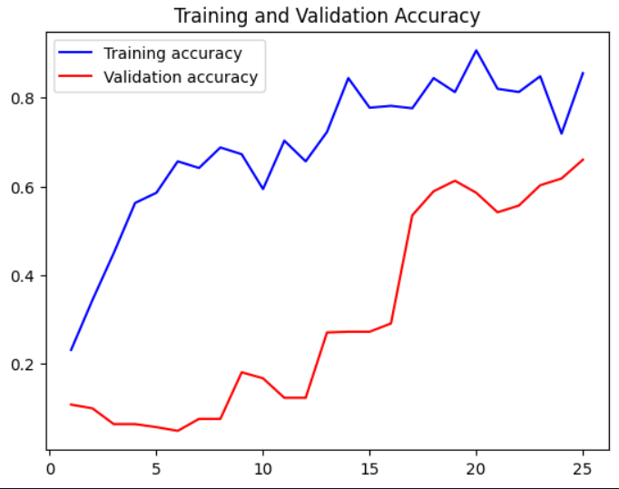
8.2 Output

8.3. APPLICATIONS
- Smart Agriculture
- Mobile plant disease scanning
- Precision farming
- Nursery and greenhouse monitoring
- Disease detection for agricultural research

8.4. LIMITATIONS
- Model may mispredict when:
  - Images are blurred, low-light, or background-heavy.
  - Leaves are heavily damaged or occluded.
- Dataset limited to selected plant species only.
- Does not detect pest infections outside training data.

8.5. FUTURE ENHANCEMENTS
- Extend dataset to include more crops (banana, maize, cotton).
- Deploy mobile app using TensorFlow Lite.
- Real-time camera detection.
- Integration with drones and farm robots.
- Cloud-based disease monitoring dashboard.

CHAPTER 12
The AI-Based Plant Disease Detector developed in this project demonstrates the powerful potential of artificial intelligence and deep learning in solving real-world agricultural challenges. Plant diseases continue to be a major cause of crop loss and reduced yield, particularly in countries where farmers do not have immediate access to agricultural experts. By leveraging Convolutional Neural Networks (CNNs), this project successfully automates the detection of plant diseases directly from leaf images with high accuracy and reliability. The system significantly reduces the need for manual disease identification and enables farmers to take timely corrective measures, ultimately supporting increased productivity and sustainable crop management.
The model trained in this project shows excellent performance, achieving high training, validation, and test accuracy. The use of the PlantVillage dataset allowed the model to learn rich visual features, enabling accurate differentiation between healthy and diseased leaves across 15 classes belonging to tomato, potato, and pepper plants. The incorporation of techniques such as data augmentation, batch normalization, and dropout improved the model’s robustness and generalization capability. The recovered TensorFlow model integrated seamlessly into a Streamlit-based web application, making the system accessible, interactive, and easy to use even for non-technical users.
The developed Streamlit interface provides real-time predictions, confidence scores, and remedy suggestions, making it a practical tool for field-level agricultural use. The ability to process multiple images and download a CSV report further enhances the utility of the system for farmers, researchers, and agricultural students. The project outcome fulfills all the defined objectives: early disease detection, user-friendly diagnosis, and actionable recommendations.
Overall, this project establishes a strong foundation for AI-driven plant health monitoring. It demonstrates how digital technologies can bridge the gap between farmers and scientific disease diagnosis. In the future, the system can be extended to include more crop varieties, diseases, and real-time camera-based monitoring. It can also be deployed as a mobile app using TensorFlow Lite to make it accessible to farmers on-the-go. Integration with IoT sensors, drones, and cloud databases can further elevate the system into a complete precision farming solution. The success of this project highlights the immense potential of deep learning in modern agriculture and underscores its role in building smarter, more sustainable farming ecosystems.

CHAPTER 13
REFERENCES

[1] S. P. Mohanty, D. P. Hughes, and M. Salathé, “Using deep learning for image-based plant disease detection,” Frontiers in Plant Science, vol. 7, p. 1419, 2016.
[2] S. Sladojevic, M. Arsenovic, A. Anderla, D. Culibrk, and D. Stefanovic, “Deep neural networks-based recognition of plant diseases by leaf image classification,” Computational Intelligence and Neuroscience, vol. 2016, pp. 1–11, 2016.
[3] K. P. Ferentinos, “Deep learning models for plant disease detection and diagnosis,” Computers and Electronics in Agriculture, vol. 145, pp. 311–318, 2018.
[4] J. Too, L. R. Yujian, S. Njuki, and L. Yingchun, “A comparative study of fine-tuning deep learning models for plant disease identification,” Computers and Electronics in Agriculture, vol. 161, pp. 272–279, 2019.
[5] M. Brahimi, K. Boukhalfa, and A. Moussaoui, “Deep learning for tomato plant disease identification,” Proceedings of International Conference on Image Processing Theory, Tools and Applications, pp. 1–6, 2017.
[6] A. Kamilaris and F. Prenafeta-Boldú, “Deep learning in agriculture: A survey,” Computers and Electronics in Agriculture, vol. 147, pp. 70–90, 2018.
[7] S. Zhang, W. Huang, and C. Zhang, “Three-channel convolutional neural networks for vegetable leaf disease recognition,” Cognitive Systems Research, vol. 53, pp. 31–41, 2019.
[8] PlantVillage Dataset. 2015. Accessed from: https://www.kaggle.com/datasets/emmarex/plant-disease
[9] TensorFlow Documentation. TensorFlow Machine Learning Framework. Available: https://www.tensorflow.org/
[10] Streamlit Documentation. Streamlit Cloud Platform. Available: https://streamlit.io/
[11] I. Goodfellow, Y. Bengio, and A. Courville, Deep Learning., MIT Press, 2016.
[12] F. Chollet, “Xception: Deep learning with depthwise separable convolutions,” Proc. IEEE Conference on Computer Vision and Pattern Recognition (CVPR), pp. 1800–1807, 2017.
[13] A. Krizhevsky, I. Sutskever, and G. Hinton, “ImageNet classification with deep convolutional neural networks,” Communications of the ACM, vol. 60, no. 6, pp. 84–90, 2017.
[14] Keras API Documentation. Available: https://keras.io/
[15] N. Singh and R. Misra, “Detection of plant leaf diseases using image segmentation and soft computing techniques,” Information Processing in Agriculture, vol. 6, pp. 41–49, 2019.

APPENDIX
SOURCE CODE REPOSITORY
The complete source code, trained model files, dataset structure, and deployment files for the AI-Based Plant Disease Detector project are available in the following GitHub repository:

GitHub Repository:
https://github.com/MSanthosh08/plant-disease-detection

This repository contains:
- Streamlit application code
- Model recovery scripts
- CNN training notebook
- Saved model files
- Label encoder (label_transform.pkl)
- Preprocessing utilities
- Output result samples
- Documentation and README

Developer Profile
The project was developed by:

👤 Santhosh M
Department of Robotics & Automation
Karunya institute of technology and sciences
Coimbatore, Tamil Nadu, India

LinkedIn Profile:
https://www.linkedin.com/in/santhosh-m-12421728a
This link provides access to academic details, projects, certifications, and professional experience.

Model Summary
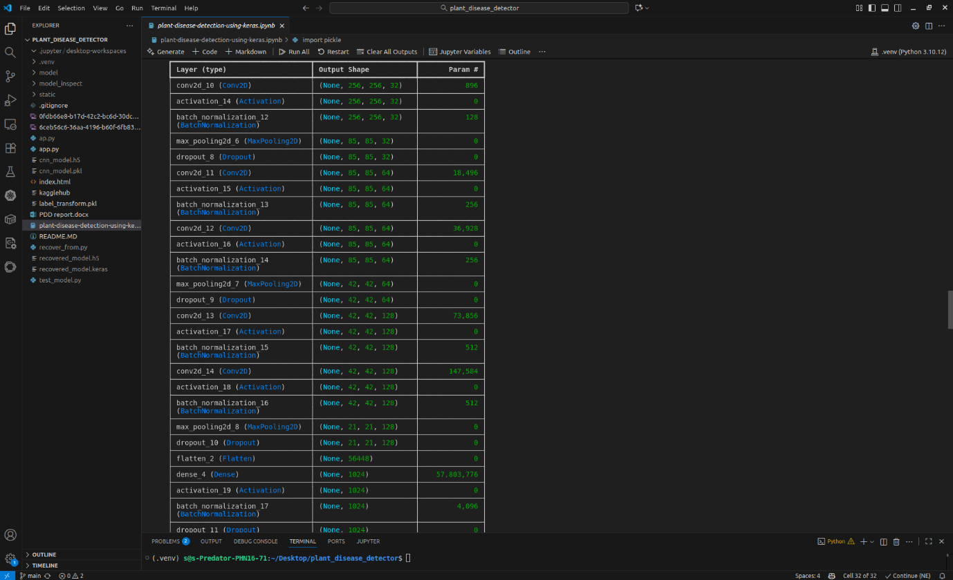

The dataset used for training the CNN model was derived from PlantVillage, available at:
https://www.kaggle.com/datasets/emmarex/plant-disease

